May 8, 2021

George Koller

**CAREGIVER AND PARENT GUIDE TO PLAYING FUNuage Level 100**

**- A programming pre-release for Pilot Testing, of Level 300**

Parental Form: **We need to know a few things like the approximate age of the child, the child’s name, the natural language, if any, that will be pronounced to the child.**

These are the major components with a few words about each:

PARENTAL FORM:

We need to know a few things from you about the Player, please be careful to enter carefully.

Child Name:

(Testing Agent of FUNuage: full name + authorizationID)

Child Age: Birth Month, Birth Year [Please be accurate!]

Natural language choices. You will see flags to choice from for each of these:

EN, DE, ES, SW and UA. English, Deutsch, Esperanto (another Constructed Language),

Swedish, and Ukrainian.

What is this about? *Bliss is not a spoken language, Bliss is a series of easy to learn*

*Pictograph and/or logic based symbols. Our game, while making the associations between real world objects and the related symbol is asking the child to make SELECTIONS,in one way or another. Upon making any selection is has proven useful to repeat the word in the Natural Language the child is targeted to learn. This is not all that will be done, but this is much of what will be happening in Level 100.*

Acceptance to allow use of data collect. We are collecting raw data for making game adjustments, but also to improve our Interface. Without this acceptance we can not adjusted

speed of the animation, and we cannot report progress to you in the Parent Dashboard.

PARENT/CAREGIVER DASHBOARD

We are using a deviation on Bliss Symbols that we call Digital Bliss designed for ease of teaching for

pre-language children. For example, we use the back of the left hand for a simplified enumeration scheme. You can thing of what is presented in Level 100 as “Bliss on Training Wheels”.

Some of the more advanced Path Stations will be using the Montessori Shapes and colors for each of

the 9 basic word types. Level 300 will eventually introduce a total vocabulary of 300 Symbols including over 150 Nouns. Level 100 has over 50 animations for basic Symbols. As Verbs are very often formed directly from Nouns a few Verbs are automatically introduced. Verbs are Red Balls to signify ACTION. So the Noun “Legs” in a red circle means To Walk.

Nouns are represented in a rectangular “Cartouche” and have one of Five Colors, for how Nouns are

classified. More about this elsewhere in the documentation.

What you should know is that each noun is prefixed by a Group Code to the left, and the Specific Symbol is to the right. There are Five NEIGHBORHOODS in the VILLAGE below conforming with this scheme.

**NOT REQUIRED READING TO LEARN TO PLAY GAME AT Level 100, but critical to understand the Neigborhoods, and Colors in the VILLAGE, also the Keyboard:**

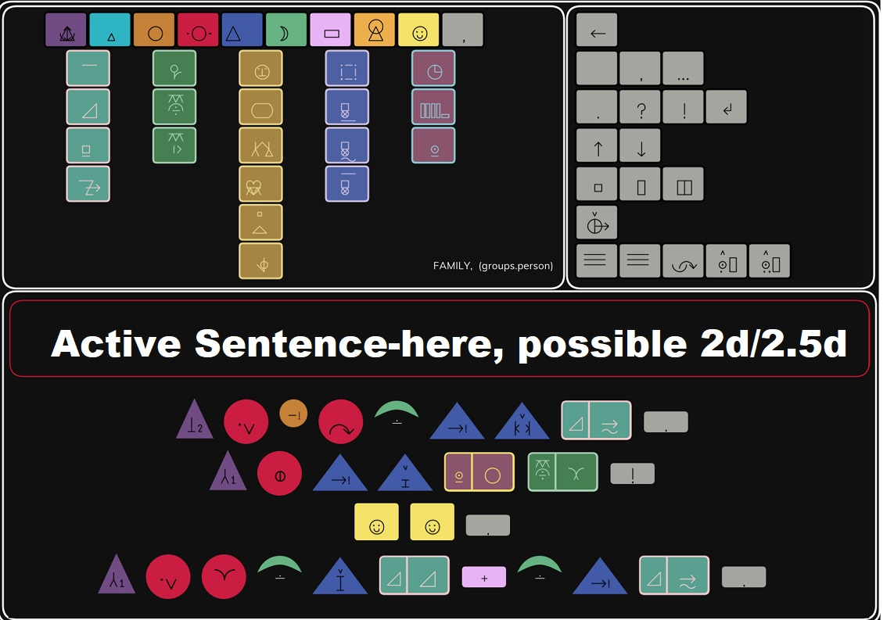

We start at the center, as this is also the center of the universe for a young child...

CENTER: – the home, and the things around the home. For the child FAMILY, PEOPLE, and intimate (things we can hold in our hands) things like the parts of our face and body, the things we use to eat like spoons and forks are all in this Group. These are things that are part of our bodies, that we use everyday, or at least things we can lift and carry around like a Shovel or Rake. Our common household pets have been allowed for in this group also. These things are a Golden **Flesh** Color.

ONE LEFT OF CENTER: PLANTS & ANIMALS – ANIMATE Things, from a blade of grass to towering Tree, in fact to an entire FOREST of trees. If it IS, or WAS alive, then it is organic,

dinosaurs are organic, and fluffy the dog. (However Fluffy is also included with PEOPLE: PETS.) Of course, even if we don’t know a Fox, from a Wolf, we all eat, and everything, but everything we eat is Organic.

ONE RIGHT OF CENTER: We have SCENES – This is the “Big and Not Animate Stuff” and we make to make our lives safer, and more convenient. There are Cars, and Houses, but also Trains, Airplanes and Bridges. Conversely these are THINGS generally bigger than what we can carry which seems to be a pretty good dividing point. (Can you carry a Bicycle? Well, we are not afraid to put some symbols into 2 or even 3 Groups, so find the one that makes seems the one most logical to you and just use that one.)

FAR LEFT are the Things and Phenomena of Nature. Mountains are in here with Streams and Clouds. Phenomena are in there like Ice, Snow, Rain and Wind. Fire is in here too. Essentially every natural thing in our environment from tiny grain of sand, from puddle to mighty ocean fits into this category.

FAR RIGHT are **CONCEPTS**. Not Stuff, but ideas we use for communications like Enumeration. Names, and Time are also in here already in Level 100. Building meaningful blocks of communications like Sentences requires more than Nouns. Special words accompany the “Thing Words” to point out things like When, Why, Where… and these things involve some basic CONCEPTS such as TIME, and COUNT, SIZE, and LOCATION.

For example, in such a classic communication situation as this one:

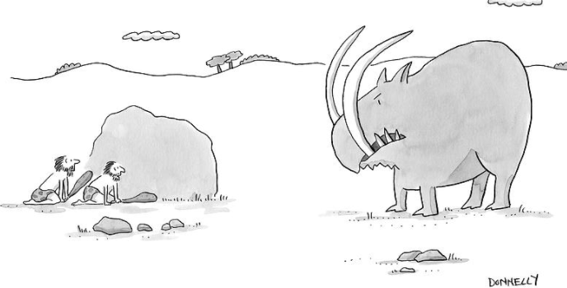

the word BIG seems essential, and Big is not a noun, and requires a concept of size.

***Note: LANGUAGE is also a SuperGROUP****. Words that are not Nouns are not of direct concern in Level 100, but will be in Level 300. And once again there is some overlap, particularly with CONCEPTS, but such is Language… There is no one way to think of things, and this scheme allows us to introduce Symbols in more or less the way a child learns language, from Mother, and Father, from Diapers, and Pillows ever more outward to include plant and animals without which we could not live with ANIMATE, and the Things we build like Houses to protect us, and Roads + Bridges to allow us to go see Grandpa, and Grandma. Then the Sun, and Stars are observed and explained to us even as Mountains and streams come to be understood parts of our environment. Likewise we become ready for general concepts like Enumeration, and Time.*

*Then, and as our world is expanding outward, we are beginning to understand fragments of communications and come to understand that “A” indicates One, and “THEY” means more than one of something Animate and so on, and so on.*

*In the keyboard these are across the top, and we use the Montessori SHAPES and COLORS to designate the NINE non-noun word and Symbol types. In addition to the Eight Traditional (non-noun) grammar elements we have included: Moji’s and Punctuation (like periods, exclamation marks, and question marks to start with). Moji’s are like the ubiquitous Smiley Face*

PLAYER –

This will be the likable young masked superhero complete with a rather magical cape.

He is your avatar, level 100 is strictly a single Player Game.

**VILLAGE -**

NEIGHBORHOODS

BUILDINGS

ANIMATION PORTALS

BEAMS (AMMO)

HUB

**GATES**

Flags/banners:

OPEN/CLOSE

**PATHS -**

STATIONS

TYPES OF PATHS:

Adventure

Digital Wizard

Village + Flag System

The FIVE Neigborhoods

Left to Right (Note: that People and our Personal stuff are in the center of our universe,

not unlike the world of a child)

WORLD

ANIMATE

PEOPLE (and our personal stuff)

CONSTRUCTION (big stuff we make)

CONCEPTS (MetaPhysics? Enumeration, names, Time)

Buildings

Animation “Portals” – This is where a lot of the initial learning is done. Essentially the child will make a connection between something we expect the child to recognize (like Legs) and will see (often) a pictograph symbol that more abstractly represents those legs. (By the way in the spirit of conserving memory, the verb “to Walk” is this simple symbol with an action indicator.)

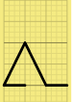

(note: NO SILLY ALPHABET!!!!, Verb formed by putting in the Red Ball – same symbol.)

Ammunition (hint in the interest of peace we make these things look like a blue bowling ball, but they sound suspiciously like StarShip Enterprise Torpedo Phasors used to destroy nervy Klingon vessels back in the 70’s.

Selecto-Beams

ExposoBeams

Gates + Flag System

Sorry budding Superhero, but even you are confined to inside the safe gates of the Village until

you have reached some level of comfort with the (Noun) Symbols.

To reflect your progress we have a visual system of Flags or Banners -

Paths - Life begins in the village, but after we have achieved a certain level of knowledge (and or experience :) ) eventually a Gate will open corresponding to your accomplishments and learning pattern,

Types:

Adventure

Digital Wizard

Stories (you read, or your caregiver reads)

Stations: Basic concept is that the stations/lessons along the way are related and build toward a

greater and greater level of understanding. You never really “fail”, but you will get

sent back to the Village to be safe and learn more basics.

This won’t be supported in Level 100, but by level 300 we expect to support outside

contributions from teachers.

I personally remember my father screaming at me because I would continually confuse ‘d’s and ‘b’s. I was convinced I was an idiot, and my father would not have argued with me. Some 70 years later I still can’t spell. And another grudge is that I learned to ride a bicycle in traffic, something that AI would have a challenge to do even now, years before I was introduced to the Simplest forms of “Logic”. This is to say I could dodge cars, and ruts in the road, estimate the speed of cars behind things, and throw my newspapers at porches years before somebody thought to show me that 0 & 0 is 0, 1 & 1 is 1 and such things as this…. Even then I was amazed, and in retrospect it hasn’t made any more sense!

If you watch about you, there are 100’s of symbols being thrown at us to turn on/off electrical devices, where to throw our trash, where your dog can or cannot do what dogs are prone to do. We process symbols by way of shapes and colors very rapidly and efficiently. On the other hand our languages were all phonetic, and rather a mess, before being matched up to an alphabet that also has a long and confusing history. So we have borrowed French words with one pronunciation, borrowed German words with another, words that sound alike but are spelled differently, words that are spelled the same but pronounced differently.

Well, we have to deal with natural languages, that is NOT the question. The real question is WHEN we have to deal with it, and what this could mean.

We know that symbols are EASIER TO LEARN. That was true in the days of rocks, and then in the days of Paper and Pencils. Studies and experience has taught us that an Auxiliary Language such as Signing (or Bliss) can be taught to people AS A BRIDGE to Natural language. Now, if a disadvantaged child can learn a system of gestures or symbols to parallel a language in the days of paper and pencils, how much faster, how much easier can an average or exceptional child learn these same symbols with animations carefully crafted to make the same connection, where we can use all the tricks of a modern Game-Engine that will adopt speed, use color, use sound, use shapes to bring the child slowly and methodically along the path as a very patient tutor, with a very good memory, and dedicated to paying attention to the child.

In some way, the 10’s of hours of crafting, and the inspiration of our artist that have gone into creating every single animation is being reproduced on call at exactly the right time, in exactly right place, at an adjusted speed.

**What’s this all about anyway?**

Compare the 4 strokes used to represent legs in Bliss Symbolics:



(in a red circle for Action)

To the Menominee word “To walk”:

P e m o e h n a e n o n

To think of Bliss REPLACING a natural language is complete and utter humbug! THIS IS NOT the question!

For ease of intuitive association, for the consistency, the conservation of memory by many clever devices conceived over 30 years of work by CKBliss. For the shear joy of feeding our innate human urge to communicate I will submit that I think I could learn the meaning of 5 or 10 symbols with the time and effort it would take me to learn to spell that Menominee word.

But anybody can conjecture, and make claims hidden behind words like “could”, so we are about to start measuring some things, establishing some solid records of the pace at which our children aged 4-7 can learn new Symbols.

There is really no way to compare the above, because before the child can “read” the “word” he must first learn the 12 arbitary symbols (letters) that make up the word. Good luck with that with a 5 year old – whatever this period of time is, I will guess that we could :) teach the child 100 symbols in less time!

Now learning 100 basic, essential Nouns is more than it might seem to be! Many/most of these nouns can be immediately & consistently turned into a Verb like legs is turned into Walk, like Bowl is turned into Carry and so on.

NOW the question becomes, okay Mr Symbols, our child knows 100 or 300 symbols, so what, what are you going to teach him?

GLAD YOU ASKED! We can make quizes, we can tell stories for the obvious and expected. But even in our level 100 we can also anchor some of the basics of Computer Programming (determining the Behavior of an actor / (simulated living) object, and let our budding programmer see the effect of his modifications.

We can boost the entertainment, and lower the academic challenge and allow the child to participate in Adventures.

We can teach about such concepts of Size, Shape, Speed, and Color. We can teach a simple system of enumeration (based on the back our the child’s left hand)

…………………

……………………

for the joy of code and decoding meaning concisely for sharing some really fun things a year, maybe more, ahead of otherwise possible

Valerii and I have been evolving a growing vocabulary of Game Terms that I'd like to document here for people that may be involved in our internal testing and for our website (also coming):  
[7:18 AM]  
The game consists of several COMPONENT systems: There is the VILLAGE, and there are GATES around the Village, and From the Village outward there are PATHS.(edited)  
[7:18 AM]  
The VILLAGE has Clusters of BUILDINGS (houses) that exist in NEIGHBORHOODS. Their are Five Neighborhoods that correspond to Our View of the (Noun) Universe. There Is a Blue (think Sky) for the Big Word of Natures Things like Mountains and Streams, like Lakes, and the Moon. Then there is a GROUP of ANIMATE Things, like Birds, and Insects. Like Animals and The Plants from the smallest blade of grass to a Forest of Trees. In the middle is a larger set of GROUPS for PEOPLE and our Intimate things that we use to brush our hair, and to hold water for drinking. Indeed, "Hold" is a distinguishing characteristic - the inanimate things in this group are "Holdable" like a shovel, but there are also things like our Eyes, and our Ears and all the parts of the body that allow use to Walk, Talk, and sense things.... Then to the right are our Bigger Things (not intimate, and not something we can hold) like Cars, like Skyscrapers and like Bridges. and now only one more of the Noun GROUPS: CONCEPTS and these are collections of such things are used for Enumeration (Numbers / Counting)/ Names that we use to speak to/about people, and how we can communicate about that thing we can call Ttime.(edited)  
[7:18 AM]  
PATH  
[7:20 AM]  
The VILLAGE (inside the gates) is where the player is introduced to Symbols, generally in logically associated groups like "FACE" will have Nose, Mouth, Eye... and so on.  
[7:26 AM]  
The MAIN (Initial) Component for Learning is the BUILDING - which is entered by the player - and the player will see (??) always Six Objects - and one at a time he player either shoots a Bowling Ball Phaser thing at the Object THAT MATCHES the Symbol on his Cape. Before starting the Player will see an animation for each Object that will start with Object (which should be recognizable by a child) and end by morphing into the Symbol,. then return to the OBJECT.  
[7:28 AM]  
The player has a choice of two Beam types: Exposo or Selecto which is a little bit of strategy, where expending a limited Selecto can be saved by using a (otherwise wasted) Exposo Beam which will cause the Object ht to cycle through an animation.  
[7:29 AM]  
Other components are for testing, and I will document them after I see them in their current release form.  
  
George Koller — Yesterday at 7:40 AM  
One PATH (the easiest to take) is appropriately named "Adventure", it requires strategic problem solving or the player will be thrown back to the village...  
May 8, 2021